[PP Slide1: Title]
[Leader: “Please join me now in prayer”]
Dear Heavenly Father, “May the words of our mouths, and the meditations of our hearts be pleasing in Your sight, our Rock and our Redeemer.” In Jesus name, amen.
Introduction:
Review:
In our first session, I described a strategy called No Hold which is rooted in, and inspired by, Jesus’ statement in John 14.
[PP slide 2: John 14:30-31]
We noted that there seems to be a dynamic relationship between reducing influence and growing influence between the two “kingdoms”.
[PP Slide 3: Inverse/build graphic]
We next identified some tactics that the devil uses to produce places of access and ownership in our lives.
[PP slide 4: Ephesians 4:25-28]
In relation to that understanding, we emphasized the role of the Holy Spirit in this dynamic process.
[PP slide 5: Ephesians 5:17-18]

In session 2, we talked about strategic structure – end point, pathways, and tactics.
We recognized our Biblical end point as full spiritual maturity,
[PP slide 6: – Eph 4:11-16]
and discussed a Biblical pathway called “standing firm”.
[PP slide 7: – Eph 6:13]
And we looked forward at several families of tactics connected to the No Hold strategy.
[PP Slide 8: Outline]
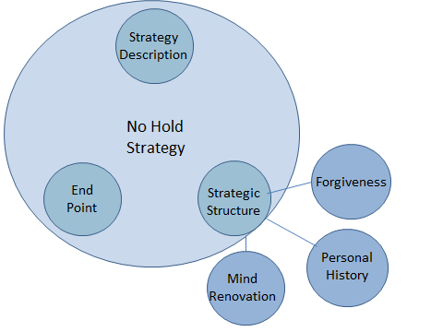
[Leader: Explain outline: These tactical families include: Forgiveness, Personal History, and Mind Renovation. Forgiveness and Personal History focus our attention on past events into present; then Mind Renovation is oriented to the present into the future. In our last class, we will return to the No Hold strategy to investigate its end point in more detail.]
In session 3 we moved forward to focus on the tactics of forgiveness connected to the No Hold strategy.
We recognized that Jesus’ criminal justice system is the context into which the tactics of forgiveness fit.
The next important concept we described in the context of forgiveness, was sin (lawlessness/criminal behavior).
The final concept we described in our last session was the activity of Satan as the accuser of the Christian believers.
We noted how forgiveness is defined:
[PP Slide 9: Definition]
aphiemi (NT:863), primarily, "to send forth, send away" [regarding] ‎(b) sins…
- ‎firstly signifies the remission [dismissal] of the punishment due to sinful conduct…
- ‎secondly, it involves the complete removal of the cause of offense
[Leader: read definition aloud beginning with the word “primarily”.]
[Leader: Remind your participants - NT or OT stands for New or Old Testament. The number is the word number in Strong’s Greek/Hebrew Definitions, and the definition is also from Strong’s reference work.]
We emphasized that a court’s sole purpose is to establish guilt or innocence and dispense justice. Mercy and forgiveness are processes that could be termed “out of court settlements”. They are related to the maintenance of social order, but provide alternative processes to actual court action.
We then defined a family of forgiveness tactics included in the No Hold strategy:
[PP Slide 10: Tactics]
- Receiving forgiveness from God
- Receiving forgiveness from others
- Granting forgiveness to others
Before we move on to today’s interactions let me say again; it’s been my experience that strategic theory is normally not too threatening.
The doing, though…actually taking some action – and living with the results - now, that’s a completely different matter.

Body:
We ended our last session thinking about a question. Let’s start at this same point today.
(Group discussion 1: Question) - 5 minutes
Starting with person #1, please discuss the following question:
[PP Slide 11: Question]
Can you think of any ways that forgiveness might reduce the devil’s influence in your life?
[Leader: read question aloud]
Remember, forgiveness exists in the reality of our guilt. We have, in some way, participated in doing kingdom of darkness tactics toward another person (or, sometimes, toward our self). In other words, we have committed a crime (or many crimes).
Another way of stating criminality is doing evil.
[DRF Note: The Bible defines evil as injury, destruction, or waste.]
Doing the tactics of forgiveness, we are able to receive forgiveness from God and others, and grant forgiveness to others (who are also able to receive forgiveness from God).
Let’s now move out of the theoretical and make it personal.
Today we will focus our attention on doing two of the forgiveness tactics, and processing the results. These tactics are:
- Receiving forgiveness from God
- Receiving forgiveness from another person
Ok, let’s start out,
(Group discussion 2: Question) - 5 minutes
Starting with person #2, please discuss the following question.
[PP Slide 12: Question]
What has been the result inside of you when you have received forgiveness?
[Leader: read question aloud]

[DRF note: It is my personal opinion that all sin, no matter who perpetrates it, or who is the victim, is ultimately against God and His government, and so will be addressed by Him.
- Our sin penalty is ultimately paid in full (Paul calls this action “being justified”) by Jesus. He takes His suffering and death to God’s court and completely pays off all our punishments with them. The court, then, has no more legal interest in our case, and releases us.
- Forgiveness is different than being justified in the court. Forgiveness is a relational solution that maintains good relations between people (in this case, between each of us and God).

Tactic 1: We confess (freely admit) our sins to God, and receive His forgiveness.
[PP Slide 13: 1 John 1:7-10]
1 John 1:7-10
7 But if we walk in the light, as he is in the light, we have fellowship [partnership] with one another, and the blood of Jesus his Son cleanses [purifies] us from all sin [lawlessness]. 8 If we say we have no sin, we deceive ourselves, and the truth is not in us. 9 If we confess [freely admit] our sins, he is faithful and just to forgive us our sins and to cleanse [purify] us from all unrighteousness. 10 If we say we have not sinned, we make him a liar, and his word is not in us. ESV
[Leader: Read the passage aloud]

(Group discussion 3: Question) - 5 minutes
Starting with person #3, please discuss the following question.
[PP Slide 14: Question]
How difficult (or easy) has it been for you in the past to seek God’s forgiveness?
[Leader: read question aloud]
(Individual practice 1: Seek forgiveness from God) – 5 Minutes
[Leader - instruct class members: For the next 5 minutes please quietly ask God to remind you of something you may need to confess (freely admit) to Him in order to receive His forgiveness. If you are willing, quietly confess it/them now and receive His forgiveness.]
Receiving forgiveness from God is a critical step since it maintains a peaceful relationship between Him and us. Receiving and granting forgiveness to other people is also important since it has the same ability to maintain peace between us.

Tactic 2: “We seek forgiveness from others” by confessing a sin we have done against them and asking them to forgive us.
This next passage comes out of James’ final instructions to the churches.
(PP Slide 15: James 5:13-16)
James 5:13-16
13 Is anyone among you suffering? Let him pray. Is anyone cheerful? Let him sing praise. 14 Is anyone among you sick? Let him call for the elders of the church, and let them pray over him, anointing him with oil in the name of the Lord. 15 And the prayer of faith will save the one who is sick, and the Lord will raise him up. And if he has committed sins, he will be forgiven. 16 Therefore, confess your sins to one another and pray for one another, that you may be healed. The prayer of a righteous person has great power as it is working. ESV
[Leader: Read the passage aloud]
[DRF Note: To confess means to freely admit. The word translated here as “sin” means unintentional errors or willful transgressions. A piece of advice: confess personal (private) sins to God alone; confess privately to a person (or persons) against whom you have sinned; only confess publically when you have publically sinned.]
(Group discussion 4: Question) - 5 - 10 minutes
Starting with person #4, please discuss the following question.
[PP Slide 16: Question]
What has been the result inside of you when you have received forgiveness from another person? [Leader: Read the question aloud]
(Individual practice 2: Seek forgiveness from someone else) – 5 Minutes
For the next 5 minutes please quietly ask God to remind you of something you may need to confess (freely admit) to another person in order to receive their forgiveness. If you are willing, make an effort this week to accomplish what God has brought to your attention.
[DRF note: Please carefully consider how this tactic might be accomplished. Approaching certain people may cause more harm than could be gained. Time, place, and circumstances all need to be taken into consideration. Ask God for good judgment.
Remember, it needs to be something of which the other person is already aware in order to avoid the embarrassing “what are you talking about?”
Also remember some advice: confess personal (private) sins to God alone; confess privately to a person (or persons) against whom you have sinned; only confess publically when you have publically sinned.]

We will pursue Tactic 3: “We grant forgiveness to others” in our next session.

[Leader: If time permits, receive and discuss questions]
What questions might you have at this time?

Conclusion
OK, so now to review:
- To forgive – a sense of laying aside; getting rid of something; letting something go; sending something away. Opposite of holding onto; keeping something close; grasping onto something
- If it’s laid aside, it’s gone.

[DRF note: I would like to share a few more personal opinions at this point:
- Forgiveness is always a personal choice.
  - It can’t be forced, purchased, or manipulated.
  - It’s one of those few pure choices that a person can make.
- Forgiveness is more of a relational issue than an emotional issue.
  - A person can be angry and still forgive.
  - You can forgive even in the middle of a very active contentious situation.
- Forgiveness is a family of tactics in the general No Hold strategy
- Able to reduce the hold of the devil’s kingdom, and increase the hold of God’s kingdom on a person’s life.]

In our next session we will interact with some issues surrounding granting forgiveness.
[PP Slide 16: forgiveness graphic]

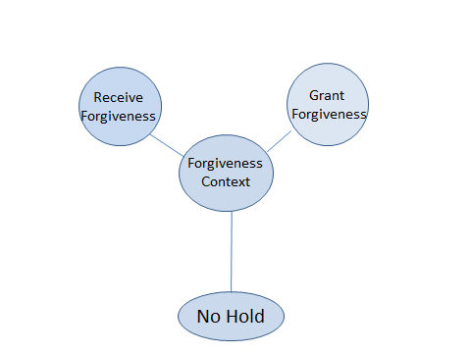

[Leader: who would be willing to close us in prayer?]

